Accessing the menus

Two menus are available in Acrobat Reader for Pocket PC: a file or document menu, and a navigation or viewing menu. The document menu provides general commands for opening new documents, setting preferences, and getting document information. The viewing menu provides commands directly related to viewing and navigating the currently open document.

To access the document menu:

Tap the menu icon located in the tool bar.

To access the viewing menu:

Tap and hold anywhere on the document.
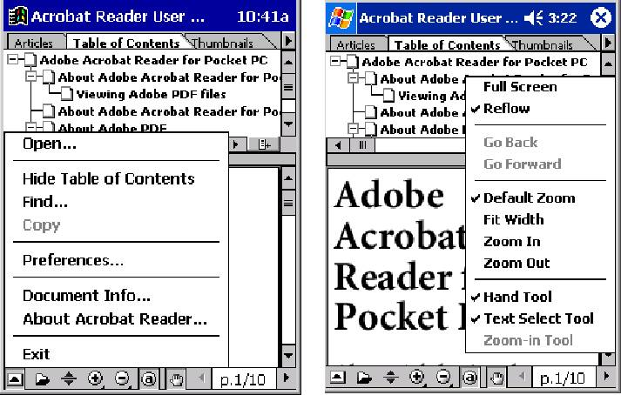

The document menu (left), and the viewing menu (right).

About the Toolbar

The toolbar is displayed along the bottom of the screen and is customizable using the Preferences dialog box. Up to 11 tool icons can be displayed, in addition to the document menu icon , which is always displayed.

The default toolbar displays the following icons in addition to the document menu icon: Open document icon, Show/Hide pane icon, Hand tool icon, Zoom in/Zoom out icons, Default zoom icon, Previous/Next page icons, and the Current page indicator/Go to page selection box

The default tool bar

Hidden zoom controls

There are four zoom controls, which are grouped together when displayed in the toolbar; The zoom in icon and zoom out icon , and the zoom in tool and zoom out tool .

If you set your preferences for all of these controls to be displayed, the zoom tools will be “hidden” under the zoom icons. For more information about how to use these controls, see “Adjusting the view of PDF documents” on page 5.

